LED Blinder

USER MANUAL

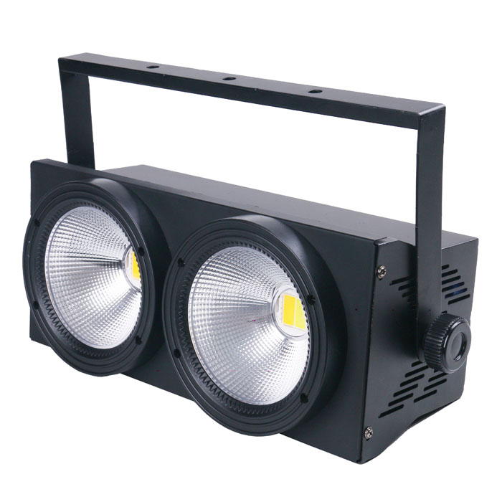

Please read and keep this manual carefully for further use!

Thank you for buying our professional Beam moving head.
This user manual includes important information for installation and operation, so please read this user manual carefully before installation and operation, and keep this user manual well for further use.
In order to install , operate, and maintain the lighting safety and correctly. We suggest that the installation and operation should be done by the verified technician and follow the instruction strictly.
Spare part includes:
Name | QTY | Unit
Fixture | 1 | PC
User manual | 1 | PC
Power cable | 1 | PC

Please check carefully that there is no damage caused by transportation. Should there be any, consult your local dealer.
Cautions
Before delivery, this device has passed strict inspection, Please follow the user manual strictly for operation, if this fixture is damaged by improper operation and mistake, the fixture will be out of warranty, and manufacture or dealer won’t be responsible for it. In case of any technology change in this manual,we won’t advise in further .



CAUTION!

Keep this device away from rain and moisture!

Unplug mains lead before opening the housing!

Warning!

Silkscreen symbol on light
Damages caused by the disregard of this user manual are not subject to warranty. The dealer will not accept liability for any resulting defects or problems.

Installation
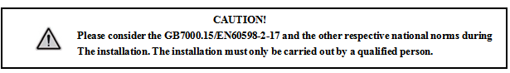

► This fixture is not suitable for direct installation on combustible material surface, please keep the fixture surface at least 0.5m from any combustible material.

► If you use the quick lock cam in hanging up the fixture, please make sure the quick lock fasteners turned in the quick lock holes correctly.
►The applicable temperature for the fixture is between -25°C to 45°C. Do not use the lighting under or above this temperature range.
►The truss for hanging the fixture should be able to hold 10 times weight of this fixture and no deformation after 1 hour hang.
►Please don’t stand under the fixture when install, uninstall, move or repair the fixture.
►Please ensure the light is connected correctly and invite professional technician to check and confirm the electrical data before installation.
►Please invite professional technician to check the fixture and installation each year.
Rigging：

Insert the quick-lock fasteners of the first holder into the respective holes on the bottom of the device.Tighten the quick-lock fasteners fully clockwise.
Fix the clamp on truss or other fixture bracket.
Pull the safety rope through the holes on the bottom of the base and fasten it on the truss or other fixing point.
Note:This step is quite important to ensure that fixture will not drop down for the clamp damage.

Product specification

Voltage：100-240V，50/60HZ；
Power Consumption：210W；
LED: LED WW/CW, 48*5050 LED
Operation mode: master-slave/DMX512/Auto/Sound
DMX Channel: 5 options (CH40/CH41/CH42/CH43/CH44 refer to the channel table)
Dimming: 0-100% linear dimming
Feature:Strobe effect
Working temp.: -30º~~45º
Strobe: 1-23Hz
Appearance: Metal, Black
Connection method: DMX512 input and output / power input and output.
IP rating: IP20

Display and operation
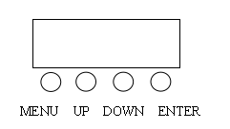
MENU | Function selection
UP | parameter increase
DOWN | parameter decrease
ENTER | Save, confirm

Display operation interface:

A001 |  | A512 | Set the address code, modify the address code (A001~A512) up or down, and ENTER to save.
FF20 |  | FF99 | Gradual change, modify the speed (FF00~ FF99) up or down,and ENTER to save.
EE20 |  | EE99 | Pulse change, modify the speed (EE00~EE99) up or down, and ENTER to save.
CC20 |  | CC99 | Jump, modify the jump speed (CC00~CC99) up or down, and ENTER to save.
Soud |  | Soud | Sound control mode
R255 |  | R000 | WW ① LED dimming, adjust LED brightness up or down (R000~R255), ENTER to save.
G255 |  | G000 | CW ① LED dimming, adjust LED brightness up or down (G000~G255), ENTER to save.
B255 |  | B000 | WW ② LED dimming, adjust LED brightness up or down (B000~B255), ENTER to save.
A255 |  | 000 | CW ② LED dimming, adjust LED brightness up or down (W000~W255), ENTER to save.
T000 |  | T--- | Display temperature, such as T045, it means the current lamp temperature is 45℃; T--- is displayed if 10K thermistor is not installed; Displaying TEMP means entering the temperature protection state.

Factory setting
At any address code A001~A512, press the menu key for 3 seconds to enter the factory setting. The factory settings are mainly the output power of each channel of the lamp, the fan setting mode, the setting of the temperature protection point, and the function of sending parameters. The factory settings,at any mode, and press the menu key for 3 seconds to exit.

R220 |  | R020 | WW ① LED dimming, adjust LED brightness up or down (R020~R255), ENTER to save.default R-220
G220 |  | G020 | CW ① LED dimming, adjust LED brightness up or down (G020~G255), ENTER to save.default G-220
B220 |  | B020 | WW ② LED dimming, adjust LED brightness up or down (R020~R255), ENTER to save.default B-220
A220 |  | A020 | CW ② LED dimming, adjust LED brightness up or down (W020~W255), ENTER to save.default A-220
FA-0 |  | FA-1 | Fan setting: the FA-0 light on to start the fan, the FA-1 reaches the set temperature protection point to start the fan, and Enter to save
T040 |  | T105 | Set the temperature protection point, modify the parameters up or down (40℃~105℃), and ENTER to save. default T-60
CH40 |  | CH44 | Channel setting, modify the channel up or down, CH40-CH41-CH42-CH43-CH44, save with the confirmation key (default CH40).
Send |  | Send | Send the factory setting parameters of the machine up or down to all other connected lamps; press the MENU key for 3 seconds to confirm the sending parameters to exit, and press the ENTER key to cancel the sending when denying the parameters.

DMX Channel Table
CH40 channel (Default)
9CH | Function | Value | Description
1 | Dimming | 0-255 | Total Brightness from low to high
2 | LED ring | 0-4 | No effect
2 | LED ring | 5-7 | Effect 1
2 | LED ring | 8-10 | Effect 2
2 | LED ring | 11-13 | Effect 3
2 | LED ring | 14-16  …  224-226 | Effect 4  …  Effect 74
2 | LED ring | 227-229 | Effect 75
2 | LED ring | 230-249 | LED ring total effect
2 | LED ring | 250-255 | LED ring Sound control effect
3 | Strobe | 0-255 | strobe, from slow to fast
4 | Macro | 0-19 | No effect
4 | Macro | 20-29 | WW①
4 | Macro | 30-39 | CW①
4 | Macro | 40-49 | WW②
4 | Macro | 50-59 | CW②
4 | Macro | 60-69 | WW①+CW①
4 | Macro | 70-79 | WW①+WW②
4 | Macro | 80-89 | CW②+WW①
4 | Macro | 90-99 | All on
4 | Macro | 100-149 | Gradual change
4 | Macro | 150-199 | Pulse change
4 | Macro | 200-249 | Jump
4 | Macro | 250-255 | Sound control
5 | Speed | 0-255 | Macro function or ring speed
6 | WW① | 0-255 | WW① Brightness from low to high
7 | CW① | 0-255 | CW① Brightness from low to high
8 | WW② | 0-255 | WW② Brightness from low to high
9 | CW② | 0-255 | CW② Brightness from low to high
CH41 channel
9CH | Function | Value | Description
1 | Dimming | 0-255 | Total Brightness from low to high
2 | WW① | 0-255 | WW① Brightness from low to high
3 | CW① | 0-255 | CW① Brightness from low to high
4 | WW② | 0-255 | WW② Brightness from low to high
5 | CW② | 0-255 | CW② Brightness from low to high
6 | LED ring | 0-4 | No effect
6 | LED ring | 5-7 | Effect 1
6 | LED ring | 8-10 | Effect 2
6 | LED ring | 11-13 | Effect 3
6 | LED ring | 14-16  …  224-226 | Effect 4  …  Effect 74
6 | LED ring | 227-229 | Effect 75
6 | LED ring | 230-249 | LED ring total effect
6 | LED ring | 250-255 | LED ring Sound control effect
7 | Strobe | 0-255 | strobe, from slow to fast
8 | Speed | 0-255 | Macro function or ring speed
9 | Macro | 0-49 | No effect
9 | Macro | 20-29 | WW①
9 | Macro | 30-39 | CW①
9 | Macro | 40-49 | WW②
9 | Macro | 50-59 | CW②
9 | Macro | 60-69 | WW①+CW①
9 | Macro | 70-79 | WW①+WW②
9 | Macro | 80-89 | CW②+WW①
9 | Macro | 90-99 | All on
9 | Macro | 100-149 | Gradual change
9 | Macro | 150-199 | Pulse change
9 | Macro | 200-249 | Jump
9 | Macro | 250-255 | Sound control

CH42 channel
9CH | Function | Value | Description
1 | Dimming | 0-255 | Total Brightness from low to high
2 | WW① | 0-255 | WW① Brightness from low to high
3 | CW① | 0-255 | CW① Brightness from low to high
4 | WW② | 0-255 | WW② Brightness from low to high
5 | CW② | 0-255 | CW② Brightness from low to high
6 | LED ring | 0-4 | No effect
6 | LED ring | 5-7 | Effect 1
6 | LED ring | 8-10 | Effect 2
6 | LED ring | 11-13 | Effect 3
6 | LED ring | 14-16  …  224-226 | Effect 4  …  Effect 74
6 | LED ring | 227-229 | Effect 75
6 | LED ring | 230-249 | LED ring total effect
6 | LED ring | 250-255 | LED ring Sound control effect
7 | Strobe | 0-255 | strobe, from slow to fast
8 | Macro | 0-49 | No effect
8 | Macro | 20-29 | WW①
8 | Macro | 30-39 | CW①
8 | Macro | 40-49 | WW②
8 | Macro | 50-59 | CW②
8 | Macro | 60-69 | WW①+CW①
8 | Macro | 70-79 | WW①+WW②
8 | Macro | 80-89 | CW②+WW①
8 | Macro | 90-99 | All on
8 | Macro | 100-149 | Gradual change
8 | Macro | 150-199 | Pulse change
8 | Macro | 200-249 | Jump
8 | Macro | 250-255 | Sound control
9 | Speed | 0-255 | Macro function or ring speed

CH43 channel
6CH | Function | Value | Description
1 | WW① | 0-255 | WW① Brightness from low to high
2 | CW① | 0-255 | CW① Brightness from low to high
3 | WW② | 0-255 | WW② Brightness from low to high
4 | CW② | 0-255 | CW② Brightness from low to high
5 | LED ring | 0-4 | No effect
5 | LED ring | 5-7 | Effect 1
5 | LED ring | 8-10 | Effect 2
5 | LED ring | 11-13 | Effect 3
5 | LED ring | 14-16  …  224-226 | Effect 4  …  Effect 74
5 | LED ring | 227-229 | Effect 75
5 | LED ring | 230-249 | LED ring total effect
5 | LED ring | 250-255 | LED ring Sound control effect
6 | Speed | 0-255 | Macro function or ring speed

CH44 channel
9CH | Function | Value | Description
1 | Dimming | 0-255 | Total Brightness from low to high
2 | WW① | 0-255 | WW① Brightness from low to high
3 | CW① | 0-255 | CW① Brightness from low to high
4 | WW② | 0-255 | WW② Brightness from low to high
5 | CW② | 0-255 | CW② Brightness from low to high
6 | LED ring | 0-4 | No effect
6 | LED ring | 5-7 | Effect 1
6 | LED ring | 8-10 | Effect 2
6 | LED ring | 11-13 | Effect 3
6 | LED ring | 14-16  …  224-226 | Effect 4  …  Effect 74
6 | LED ring | 227-229 | Effect 75
6 | LED ring | 230-249 | LED ring total effect
6 | LED ring | 250-255 | LED ring Sound control effect
7 | Strobe | 0-255 | strobe, from slow to fast
8 | Macro | 0-49 | No effect
8 | Macro | 20-29 | WW①
8 | Macro | 30-39 | CW①
8 | Macro | 40-49 | WW②
8 | Macro | 50-59 | CW②
8 | Macro | 60-69 | WW①+CW①
8 | Macro | 70-79 | WW①+WW②
8 | Macro | 80-89 | CW②+WW①
8 | Macro | 90-99 | All on
8 | Macro | 100-149 | Gradual change
8 | Macro | 150-199 | Pulse change
8 | Macro | 200-249 | Jump
8 | Macro | 250-255 | Sound control
9 | Speed | 0-255 | Macro function or ring speed

DMX-512 connection

Connect the provided XLR cable to the male 3-pin XLR output of your controller and the other side to the female 3-pin XLR input of the light.then connect the DMX signal to the first fixture to the 2nd fixture, after all fixtures are connected,

The signal cable should be two - core with screened cable with XLR input and output connectors.

DMX terminator connection
If there are many lines or lights, it is recommended to use a DMX terminator to prevent DMX signal corruption, the DMX terminator is an simple XLR plug with a 120 Ω resistor connected between pins 2 and 3,which is then plugged into the output XLR socket of the last fixture in the chain.
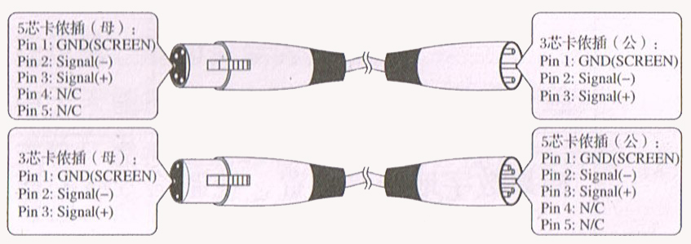
3-Pins connection
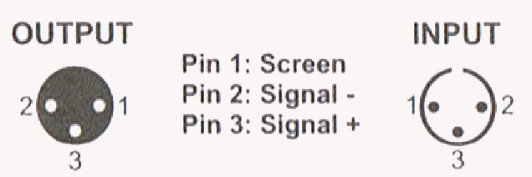

Cleaning and maintenance

Cleaning should be performed every 15-day period, by using a sponge which is dipped with alcohol, rather than wet cloth or other chemical liquid, to clean the mirror.

Cut off power before cleaning and maintenance!
CAUTION

Attention

Do not see directly light source when open the light, and make sure power off before do any installation or maintenance.

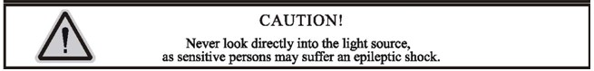
 Wires connection must be done professional person!
CAUTION

Cautions
Before delivery, this device has passed strict inspection, Please follow the user manual strictly for operation, if this fixture is damaged by improper operation and mistake, the fixture will be out of warranty, and manufacture or dealer won’t be responsible for it. In case of any technology change in this manual,we won’t advise in further .

Note: the maintenance should be done by the verified technician.

Warranty Card
This product is made of high-brightness transistor. We will provide 1 year warranty under the condition that user has operated the light normally and lifetime service. We won't provide warranty if the damage is caused by artificial or force majeure event. Cost of fittings should be charged by user if product need maintenance after 1 year .Please cut this warranty card and shipped it along with the product to our factory when applying for warranty.
Product：
Purchasing date：
Code of invoice：
Warranty date: From To
User’s name： Add：
Company： Tel：

